Lesson 7-3: Functions with Value Parameters

Exercise 1:

// Program Shell2 promps for the number of dollar signs for
// the top of the box. That number / 2 - 2 lines are
// printed with dollar signs on the sides.

#include <iostream>
#include <iomanip>

using namespace std;

void Print(int numSigns); //Function prototype
//Post: A defined box is printed using the number of money signs input by user.

int main ()
{
int number = 0;

cout << "Enter the number of dollar signs for the top; "
<< "press return. " << endl;
cout << "Enter end-of-file characer (#) to quit." << endl;
cin >> number;
if (number == '#')
return 1;
else
Print(number);

cout << endl
<<"Enter the number of dollar signs for the top; "
<< "press return. " << endl;
cout << "Enter end-of-file characer (#) to quit." << endl;
cin >> number;
if (number == '#')
return 1;
else
Print(number);

system("pause");
return 0;
}

//**************************************

void Print(int numSigns) //Name of function
//Post: A defined box is printed using the number of money signs input by user.

{ //Begin Action
int topCount = 1;
int bottomCount = 1;
int countRows =1;

int insideSpacing;
insideSpacing = (numSigns/2)-1;

while(topCount <= numSigns) //Displays Top
{
cout << "$";
topCount++;
}

cout << endl;

while(countRows < insideSpacing) //Displays Inside
{
cout <<"$" << setw(numSigns-1) << "$" << endl;
countRows++;
}

while(bottomCount <= numSigns) //Displays Bottom; is identical to Top
{
cout << "$";
bottomCount++;
}

cout << endl;

return;
} //End Action

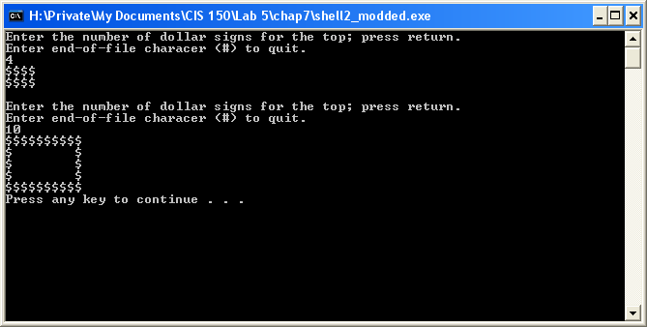
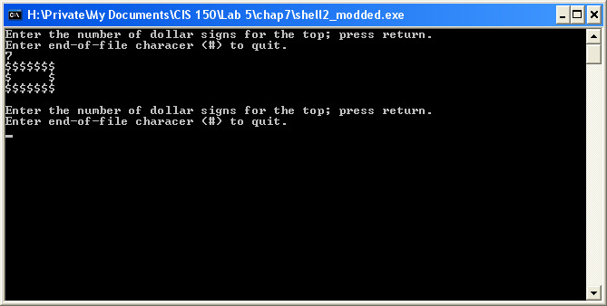

Lesson 7-4

Exercise 1:

// Program Shell3 reads miles and hours and prints miles
// per hour.

#include <iostream>
#include <iomanip>
using namespace std;

void GetData(float&, float&); //Prototype

int main ()
{
float miles;
float hours;
float milesPerHour;

cout << fixed << showpoint;

GetData(miles,hours);

milesPerHour = miles / hours;
cout << setw(10) << miles
<< setw(10) << hours
<< setw(10) << milesPerHour << endl;

system("pause");
return 0;
}

//*****************************************************

void GetData(float &miles, float &hours)
{
cout << "Enter number of miles ";
cin >> miles;
cout << "Enter number of hours ";
cin >> hours;
return;
}

